**Add revisions to API Management Apps**

When your API is ready to go and starts to be used by developers, you eventually need to make changes to that API and at the same time not disrupt callers of your API. It's also useful to let developers know about the changes you made. We can do this in Azure API Management using revisions.

1. Select **APIs** page.
2. Select **Demo Conference API** from the API list (or other API to which you want to add revisions).
3. Click the **Revisions** tab from the menu near the top of the page.
4. Select **+ Add Revision**

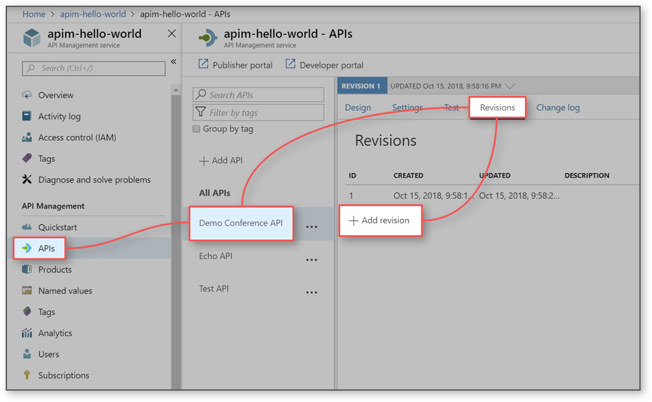

1. Provide a description for your new revision, to help remember what it will be used for.
2. Select **Create**

Your new revision is now created. **Your original API remains in Revision 1. This is the revision your users continue to call, until you choose to make a different revision current.**

**Make non-breaking changes to your revision**

1. Select your from the API list.
2. Select the Design tab near the top of the screen.
3. Notice that the revision selector (directly above the design tab) shows Revision 2 as currently selected.

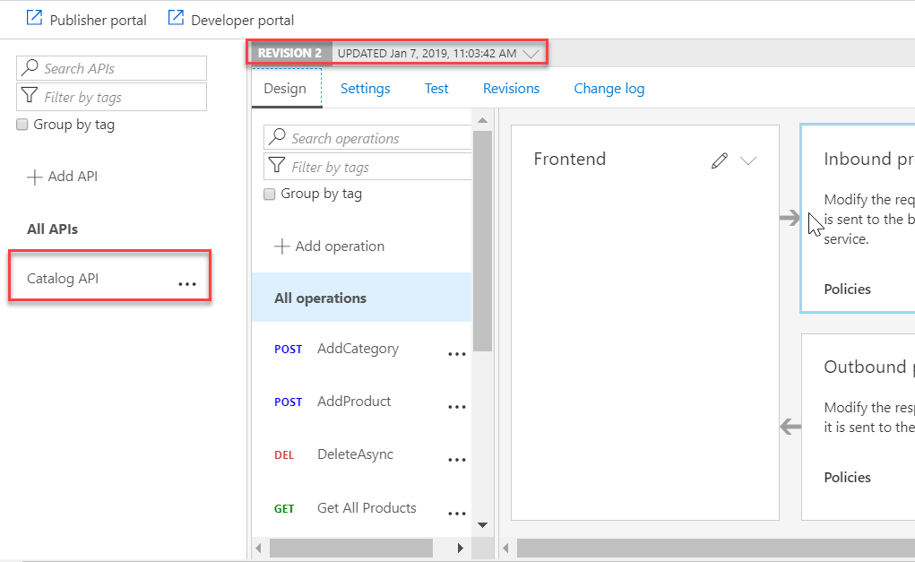

1. Select **+ Add Operation**.
2. Set your new operation to be POST, and the Name, Display Name and URL of the operation as test.

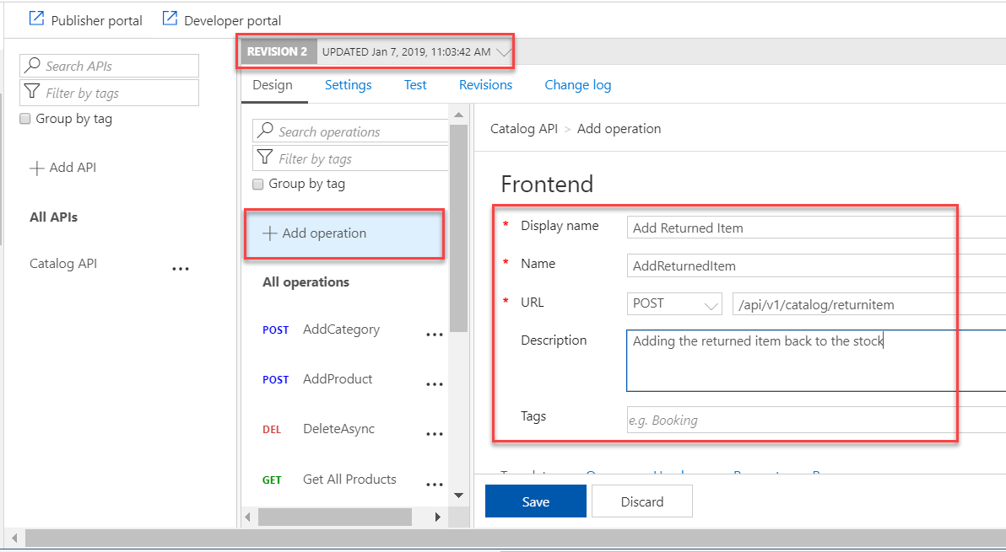

1. Save your new operation.
2. We have now made a change to Revision 2. Use the Revision Selector near the top of the page to switch back to Revision 1.
3. Notice that your new operation does not appear in Revision 1.

**Make your revision current and add a change log entry**

1. Select the Revisions tab from the menu near the top of the page.

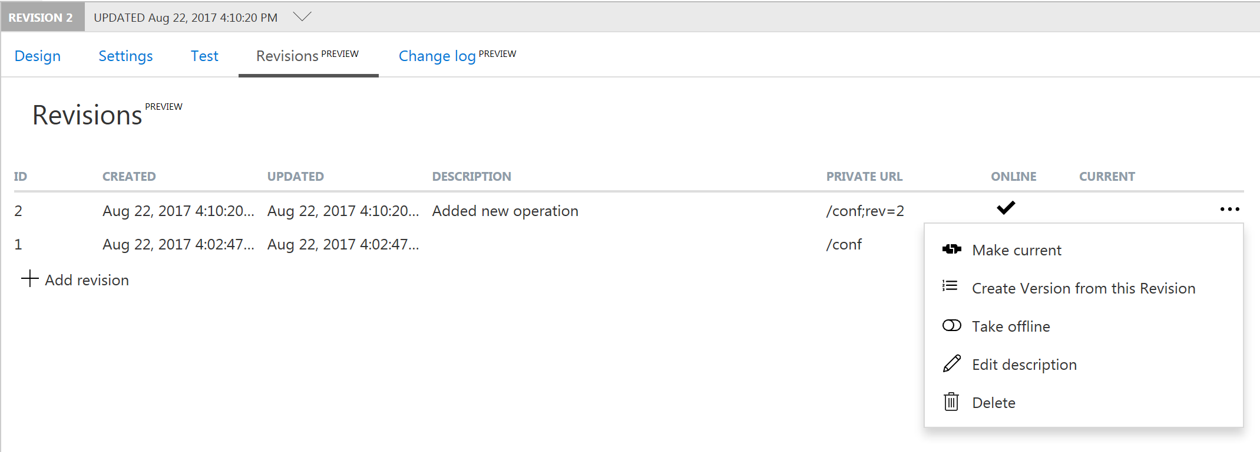

1. Open the context menu (...) for Revision 2.
2. Select Make Current.
3. Check Post to Public Change log for this API, if you want to post notes about this change. Provide a description for your change that developers see, for example: Testing revisions. Added new "test" operation.
4. Revision 2 is now current.

**Browse the developer portal to see changes and change log**

1. In the Azure portal, select APIs.
2. Select Developer Portal from the top menu.
3. Select APIs, and then select your API.
4. Notice your new test operation is now available.
5. Select API Change History from below the API name.
6. Notice that your change log entry appears in this list.

